First Grade Classroom Supply List

We are so excited for the new school year to begin! There are some supplies that our classroom needs for the upcoming year. It would be helpful if your child could bring some or all of the “Required Supplies” listed below. We have also included a “Wish List.” These items are not required, but would be greatly appreciated!

Required Supplies:
(2) Boxes of Kleenex
(1) 24 pack Boxes of Crayola Crayons
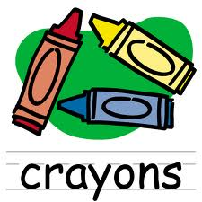
(1) 8 pack Crayola Washable Markers (Classic Color)
(1) Pack Elmer’s Washable Glue Sticks
(1) Bottle Elmer’s Glue
(1) Box of Baby Wipes
(2) Clorox Wipes
(3) 2 Pocket Folders with Fasteners (solid colors only)
(2) Bottles of Hand Sanitizer
(1) Pack Expo Dry Erase Markers (thick)
(1) Box of Band-Aids
(1) Child-safe scissors
(1) Pack of No. 2 pencils

Wish List – Appreciated donations for the whole class to use:
Books on CD/tape
Stickers
Fun erasers
Stamps/Ink pad
Construction paper (variety pack)

Your child will also need tennis shoes that are comfortable to run in for P.E. class and for going outside during Environmental Science.

Please DO NOT label the supplies with your child’s name. All classroom supplies are shared within our classroom. We thank you in advance for your generosity!

